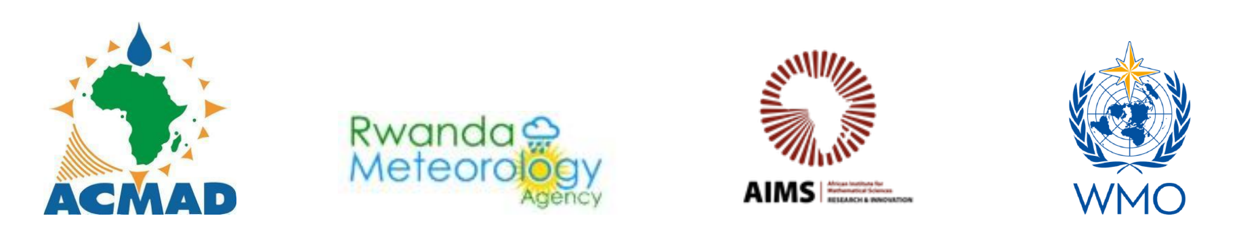
FOR IMMEDIATE RELEASE
Kigali, Rwanda, 19 October 2026

African Summer School Opens in Kigali to Build Africa's Capacity in AI for Weather and Climate Modelling
ACMAD, WMO and AIMS launch a five-day programme to help African institutions adapt and apply AI-enabled forecasting and early warning tools
KIGALI, Rwanda: The African Summer School on Artificial Intelligence for Weather and Climate Modelling 2026 opened today at the African Institute for Mathematical Sciences (AIMS) in Kigali. The school brought together 40 participants from 21 African countries. The five-day programme is organised by the African Centre of Meteorological Applications for Development (ACMAD).
At the opening, ACMAD Director General Dr. Osumane Ndiaye called for stronger African capacity in artificial intelligence and climate modelling. He said the technology should serve practical needs, including helping communities anticipate weather hazards and helping African researchers answer locally specific questions, such as when rains will begin. “Our best adaptation strategy is early warning,” Dr. Ndiaye said, stressing the need for climate information that people can understand and act on. He said the school drew 1,161 applications and described it as a starting point for an African-led community connected to the global climate-modelling field.
Prof. Sam Yala, President of the AIMS Network, said artificial intelligence could strengthen the region’s forecasting and early warning systems. He said AI and machine learning can complement established weather and climate models, analyse complex datasets, improve forecasts, support downscaling and bias correction, and strengthen the monitoring of extreme events. “Technology alone is not enough,” Prof. Sam Yala said. The real impact, he said, depends on people who can evaluate these tools’ limitations and apply them responsibly to local challenges. He called on African scientists and institutions to contribute to the design, validation, adaptation and operational use of these tools, rather than only using technologies developed elsewhere.
Over the week, participants will combine expert-led lectures, hands-on coding, peer learning and group projects using African weather and climate data. Topics include AI and machine learning fundamentals, key datasets such as station observations, satellite products and reanalysis, data preprocessing with CSV, NetCDF and GRIB files, and model evaluation. The programme closes with institutional application plans, a community of practice, and certification.
ACMAD says the school is designed as the first step in a longer programme. It plans an online community of practice, shared training resources and mentorship sessions, and lessons from each edition will shape future curricula.
About the organisers and partners
- ACMAD (African Centre of Meteorological Applications for Development) is a Regional Climate Centre for Africa with a continental mandate, established in 1985 for the purpose of: the understanding of atmospheric and hydrologic processes over Africa; collecting, analysing and disseminating Climate Information Services; developing climate applications, providing a meteorological watch and early warning system over Africa and promoting the training of African scientists and technicians in the application of meteorology for development
- AIMS (African Institute for Mathematical Sciences) is a Pan-African network that builds scientific talent through education, research and innovation in the mathematical sciences.
- WMO (World Meteorological Organization) is the United Nations specialised agency for weather, climate and water.
Partners include AIM for Scale, NORCAP (part of the Norwegian Refugee Council), AfriClimate AI, and the Rwanda Meteorology Agency.

Media contact:
Sandrine Wendlasida Combere
ACMAD
Email: accof@acmad.org

